Bahria University,

Karachi Campus



LAB EXPERIMENT NO.

___03___

LIST OF TASKS

|  |  |
| --- | --- |
| TASK NO | OBJECTIVE |
| 01 | Run the following commands on the command prompt of your PCs and attach snapshots of the result:   * ping [www.google.com](http://www.google.com) * tracert [www.yahoo.com](http://www.yahoo.com) * ping -i 6 www.facebook.com, did you receive the correct reply? If not, explain why. * nslookup www.live.com, did you result show ‘Non-authoritative answer’? If yes, explain what does it indicate, you are advised to browse the internet to attain this answer. * Differentiate between Ping and PathPing commands. * Find all Active/ Used IP addresses on your network. * How to verify connection with remote computer? |
|  |  |
|  |  |
|  |  |

Submitted On

11-10-2023

(Date: DD/MM/YY)

**Task 01:** Run the following commands on the command prompt of your PCs and attach snapshots of the result:

**Solution:**

1. **ping** [**www.google.com**](http://www.google.com) **:**

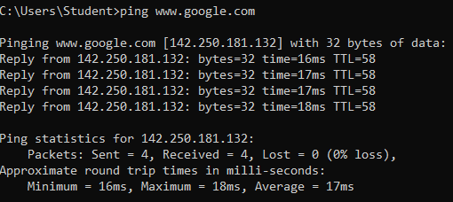

1. **tracert** [**www.yahoo.com**](http://www.yahoo.com)

1. **ping -i 6 www.facebook.com, did you receive the correct reply? If not, explain why.**

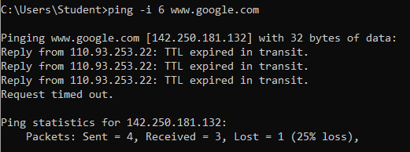

Because this server is very far and I got only 6 seconds between each ping request. As well as there are many reasons in which some are following:

* Firewall or Security Settings: Your firewall or security settings could be blocking the ping requests or replies.
* DNS Resolution: If the DNS resolution for "www.facebook.com" is not working correctly, your computer may not be able to find the correct IP address to ping.\
* Facebook's Server Response: Facebook's servers might not respond to ping requests, as many websites and servers are configured not to respond to ping for security reasons.

1. **nslookup www.live.com, did you result show ‘Non-authoritative answer’? If yes, explain what does it indicate, you are advised to browse the internet to attain this answer.**

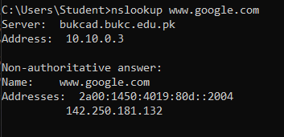

Yes , Non-authoritative answer simply means the answer is not fetched from the authoritative DNS server for the queried domain name.

1. **Differentiate between Ping and PathPing commands.**

* **Ping**:

We get the latency and packet loss between the source and the destination. Ping is a basic command-line utility used to test network connectivity between two devices. It sends ICMP echo request packets to a target IP address or hostname and waits for an ICMP echo reply. Ping provides a simple way to check if a remote host is reachable and measure the round-trip time for packets to reach the destination and return.

* **Pathping**:

we get a list of all the routers between the source and the destination, as well as the latency and packet loss between all the routers along the way and the source. PathPing, on the other hand, extends the functionality of Ping. It not only tests connectivity to a target but also provides information about the path taken by packets to reach the destination. It shows hop-by-hop latency and packet loss information for all the routers or devices along the route. PathPing is useful for identifying network issues along the entire path to a destination, helping to pinpoint where problems may be occurring.

1. • Find all Active/ Used IP addresses on your network.

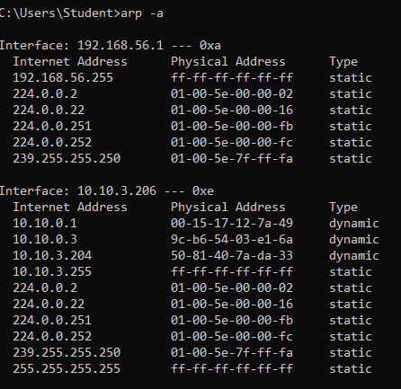

1. • How to verify connection with remote computer?

**Task No. 5:** Ping Parameters

1. **Ping -t:**

1. **Ping -a**

1. **Ping -w**

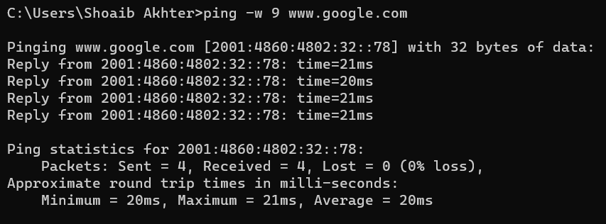

1. **Ping -v tos**

1. **Ping -l 70 :**

